**Review 1:**

Before:

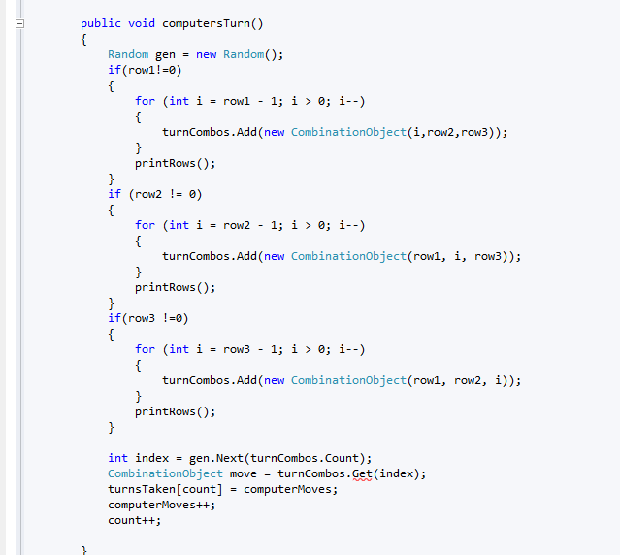

* Rule: Extract Class
* Reason:

Pic After

B4

* Rule: Extract Class
* Reason:

Pic After

B4

* Rule: Extract Class
* Reason:

Pic After